**The Evolution of Dedicated Cycling Infrastructure in Three Canadian Cities from 2009 to 2022**

Linda Rothman,a Richard Wenb, Andrew Howardc, Konrad Samsela,b, Meghan Wintersd, Moreno Zanottod, Brent Hagele, Colin Macarthurc, Brice Batomenb

Affiliations:

1. School of Occupational and Public Health, Toronto Metropolitan University, 350 Victoria Street, Toronto ON M5B 2K3
2. Dalla Lana School of Public Health, University of Toronto, 155 College Street, Toronto ON M5T 3M7
3. Child Health Evaluative Sciences, SickKids Research Institute, 686 Bay St, Toronto, ON, Canada M5G 0A4
4. Faculty of Health Sciences, Simon Fraser University, 8888 University Drive, Burnaby, BC, Canada, V5A 1S6
5. Departments of Pediatrics and Community Health Sciences, Cumming School of Medicine, University of Calgary, C4-434, Alberta Children’s Hospital, 28 Oki Drive NW, Calgary, AB, Canada, T3B 6A8

**Address Correspondence to: Richard Wen**

Department of Public Health Sciences,

University of Toronto,

155 College Street,

Toronto ON M5T 3M7

(richard.wen@utoronto.ca)

**ABSTRACT**

**Introduction (250 words- currently 269)**

Canadian municipalities have started to prioritize cycling within urban centers,. Accurate cycling infrastructure data is required for planning and to assess the effectiveness of different types of infrastructure. This study verified cycling infrastructure data and examined trends in installation e in Vancouver, Calgary, and Toronto, Canada –from 2009 to 2022.

**Methods**

The study focused on on-street cycling infrastructure s, which were painted lanes, buffered lanes, cycle track and local street bikeways. Municipal reports of new installations and upgrades occurring between 2009 and 2022 were verified using grey literature, and historical street view imagery. The Canadian Bikeway Comfort and Safety (Can-BICS) classification system, provided consistent classification of infrastructure, enabling comparison of installation across municipalities and over time.

**Results**

Installation date verification found 83% accurately matched Vancouver’s municipal reports, with 42% matching in Calgary and 75% matching in Toronto.

Verification indicated 6 km more infrastructure in Vancouver, 1.5 km less for Calgary and 19 km more infrastructure in Toronto as compared to municipal reports, with the greatest differences in painted lanes in Toronto.

There was a two-fold increase in infrastructure in Vancouver (19.2 to 34.2 km per 1000 km) and Toronto (18.7 to 40.2 km per 1000 km), and an eleven-fold increase in Calgary (1.2 to 11 km per 100 km). There was a marked acceleration of cycling infrastructure implementation in Calgary and Toronto from the onset of the COVID-19 pandemic.

**Conclusion**

More attention is required in collecting accurate infrastructure data by municipalities. All three cities showed an expansion of dedicated cycling infrastructure from 2009-2022, with a focus on separated cycle tracks infrastructure reflecting an urban planning shift towards safer cycling infrastructure

Keywords: cycling, infrastructure, cycle tracks, trends, verification

Funding: This work was supported by the Canadian Institutes of Health Research [grant number FRN: MM1- 174905].

Highlights (3-5 bullet points): (max 85 characters including spaces)

* Accurate cycling infrastructure data is required to assess effectiveness
* Verification of infrastructure data found discordance with municipal reports
* Infrastructure installation has greatly accelerated since 2009
* A marked acceleration is evident since the onset of the COVID-19 pandemic

1. Introduction

Recognizing the significance of sustainable mobility, Canadian municipalities are intensifying efforts to enhance active transportation infrastructure, for mobility, environmental, and health impacts (1,2). This approach has the potential to alleviate transportation demands and align with broader environmental targets (3,4). Consequently, many large Canadian cities have made considerable progress in building new bikeways and upgrading infrastructure to create active spaces for individuals of all ages and abilities (5).

The challenge of road safety persists as a pressing public health concern with an immense human and economic burden (6). For example, in Toronto, Ontario, 858 cyclists suffered injuries (812 major and 46 fatal injuries, respectively) between 2006 to 2023 (7), which associated direct and indirect economic costs of more than $60 million per year (8). Across Canada, the costs of cycling injuries in 2018 was 377 million CAD (9). In addition to public health impacts, the perceived risk of injury associated with on-street cycling may also deter its adoption as an alternative transportation option (2). Aligned with urban planning initiatives, the Vision Zero road safety strategy, launched in Sweden in 1997 and now adopted in cities globally, stands as a crucial guiding principle for road safety (10–12). Vision Zero strives to eliminate all severe and fatal road transportation injuries while promoting healthy and equitable mobility for all. Unlike traditional approaches that place burdens of safety on road users, Vision Zero acknowledges human error and focuses on road system designs to prevent traffic deaths (10–12). One of the key components in Vision Zero, is the installation of cycling infrastructure, to improve safety and encourage cycling as a sustainable transportation mode (13).

All ages and abilities cycling facilities (referred to’ AAA”) is the goal in cities, reflecting infrastructure that is well connected and safe and comfortable for everyone, AAA facility are protected bike lanes, off-street paths and local street bikeways, and not painted bike lanes or shared lanes for motor vehicles and bikes (14–16).n the context of on-street infrastructure, cyclists prefer cycling infrastructure to none, and cycle tracks – where cyclists are physically separated from vehicle traffic – to painted lanes (17). Only 15% of cyclists responding to an online survey, perceive mixed traffic routes (e.g., no infrastructure) as being safe; however, perception of safety increases to 77% for painted lanes, and up to 91% when physical barriers are part of the infrastructure (18).

The COVID-19 pandemic also pushed municipalities to respond to shifting mobility patterns and emerging public health needs (19). As cycling ridership surged across Canada during the pandemic, injuries increased, with approximately 43,700 cycling-related emergency department visits from April 2020 to March 2021, reflecting a 36% increase from the previous year (20–22). With the anticipation that increased ridership will persist in the coming years (23), municipalities must take proactive steps to design active transportation networks that safely accommodate higher volumes. In order to do this, it is important to accurately determine what cycling infrastructure exists and has emerged over time and ultimately, evaluate the effectiveness of this infrastructure in terms of safety. Data quality related to cycling infrastructure has been poor due to misclassification as a result of inconsistent nomenclature, , or missing cycling installation data (24,25).

The overall objective of our research was to describe trends in the installation of on-street cycling infrastructure in three Canadian cities - Vancouver, Calgary, and Toronto - from 2009 to 2022. This study is part of the RECOVR initiative (**R**oad-safety **E**valuation during **CO**VID-19 among **V**ulnerable **R**oad Users in Canada), a broader research effort funded by the Canadian Institutes of Health Research, which included 4 Canadian cities; Montreal, Toronto, Calgary and Vancouver. Although there have been previous studies evaluating cycling infrastructure data, including in Canada (24–27) and their associations with cycling safety (28–30), accessibility (31,32), and demand (33–37), there has been little work done that focuses on the verification of implementation dates and changes over time in cycling infrastructure across Canadian cities. Thus, our specific objectives are 1. to compile and verify cycling infrastructure over 13 years in 3 Canadian cities and 2. to document the trends in the implementation of dedicated cycling infrastructure.

2. Methods

2.1 Study setting

The cities included in this study, were 3 of the cities in the RECOVR initiative, which are 3 of the most populous cities in Canada. Table 1 describes city demographics, roadway infrastructure, and bikeway network as reported by the municipalities. Vancouver had the highest population density with 5,758 individuals/km2 and 84% of its roadways were designated as local streets. Notably, 11.9% of roadway-km within the municipality had cycling routes, including dedicated cycling infrastructure, local street bikeways (residential streets with cycling facilities), and shared roads (roads shared by bikes and vehicles). Calgary had a population density of 1,583 individuals/ km2, 65% of its roadway network was local streets, and 7.2% of roadway-km had cycling routes. A standout feature of Calgary’s active transportation infrastructure was its extensive network of paths, with a total length of 1,012 km, as compared with Vancouver’s 77.5 km and Toronto’s 365.9 km of off-street paths. Finally, Toronto, the most populous municipality in the study, had a density of 4,434 individuals/ km2, with 66% of its roadways designated as local streets, and only 7% of roadway-km with cycling routes.

|  |  |  |  |  |
| --- | --- | --- | --- | --- |
| **Municipal Attributes** | | | | |
|  | **Measure** | **Vancouver** | **Calgary** | **Toronto** |
| **Demographics**  **(2021)** | Population | 662,248 | 1,306,784 | 2,794,356 |
| Area (km²) | 115 | 825.3 | 630.2 |
| **Density** (Pop. per km²) | **5,758** | **1,583** | **4,434** |
| **Municipal Roadways** a  (2022, centreline-kilometers) | Arterial | 221.6 | 1,402.1 | 1153.7 |
| Collector | 132.7 | 1331.9 | 767.1 |
| Local | 1869.4 | 5197.3 | 3658.6 |
| **Roadways, Total** | **2,223.7** | **7,931.3** | **5,579.4** |
| **Municipal Bikeways and Pathways** b  (2022, centreline-kilometers) | Path *(Off-Street)* | 77.5 | 1,012 | 365.9 |
| Cycle Track *(On-Street)* | 27.4 | 31.7 | 73.9 |
| Painted Lane *(On-Street)* | 43.8 | 57.0 | 131.5 |
| Shared Roads *(On-Street)* | 193.3 | 481.0 | 184.4 |
| Local Street Bikeways *(On-Street)* | 175.8 | N/Ac | N/Ac |
| **On-Street Routes, Totald** | **264.5** | **569.7** | **389.8** |
| **All Routes, Totald** | **342.0** | **1,581.7** | **755.7** |
| **Cycling Route Coverage**  (by cen-km) | **% Roadway-km with routes** | **11.9%** | **7.2%** | **7.0%** |
| cen-km: centreline-kilometers, length of a route measured along its central axis.  *a: Total Centreline-km of Public Roadways in Vancouver, Calgary, and Toronto. Excluding Highways, Skeletal Roads, and non-municipally operated roads. Local roadways denote residential streets and lanes.*  *b: Total centreline-km of municipally operated bikeways and pathways, excluding planned infrastructure, temporary infrastructure, and decommissioned infrastructure. Analyzed directly from municipal data, prior to the exclusion of misclassified segments.*  *c: N/A No local street bikeways as per the Can-BICS classification*  *d: Not including local street bikeways* | | | | |

**Table 1: Comparison of Municipal Roadway and Bikeway Infrastructure in Vancouver, Calgary, and Toronto (Canada), 2022.** Information downloaded from municipally maintained open datasets Methodology and detailed download dates available in ***Appendix 2***.

2.2 Data Sources

Cycling network data were acquired from open data repositories maintained by the municipalities of Vancouver, Calgary, and Toronto in January 2023 (38–40). Within these datasets, cycling infrastructure is divided into individual segments, representing city blocks (Vancouver and Calgary), or correspond to entire installations (Toronto).

2.3 Inclusion and Exclusion Criteria

*Dedicated cycling infrastructure located on public roadways*, specific infrastructure classifications pertaining to painted lanes, buffered lanes, and cycle tracks were eligible for inclusion. To ensure methodological consistency and account for potential disparities in the inclusion of decommissioned infrastructure within municipal data, only infrastructure that was permanently installed and active in 2023 included.

Segments of cycling infrastructure categorized as off-street paths, shared roadways, or mixed-use paths were excluded from the analysis. Moreover, any segments classified as a temporary installation were removed. Duplicate entries with the same polyline coordinates were identified and removed. Street imagery was used to review and confirm (or delete) each segment’s classification, leading to the removal of infrastructure consistent with the specified exclusion criteria.

2.4 Infrastructure Classification

A standardized classification criterion was applied across cities, based on the Canadian Bikeway Comfort and Safety (Can-BICS) classification system (17), including the categories cycle tracks and painted lanes, which comprise of on-street cycling infrastructure. For this analysis, the Can-BICS painted lane classification was further subdivided into two distinct types: painted lanes and buffered lanes. This distinction facilitated a more detailed analysis of infrastructure trends and was influenced by previous research from Australia that observed an increased passing distance between motorists and cyclists when infrastructure consisted of buffered lanes as compared to painted lanes (41), potentially improving perceived safety and reducing the risk of collisions.

Three categories of infrastructure were considered, including painted lanes, buffered lanes, and cycle tracks. Painted lanes were characterized by solid or dashed lines separating cyclists from vehicle travel lanes, accompanied by signs or pavement markings to distinguish them as cycling routes. Buffered lanes shared similar features; however, were distinguished by a wider painted area marked with diagonal or chevron patterns. Cycle tracks were defined based on the presence of a permanent vertical barrier such as bollards or raised curbs. In situations where different infrastructure was present on opposite sides of a roadway, the segment’s classification was determined by the most protective element. Detailed information on the classification criteria is provided in ***Appendix 2***.

2.5 Installation dates

We documented the year of installation or upgrade by various methods. An installation was defined as the introduction of dedicated cycling infrastructure on a roadway where no prior dedicated infrastructure existed within the study period. An upgrade was defined as the modification of existing dedicated cycling infrastructure, resulting in reclassification of the segment. Following the identification of eligible segments from municipal data, a verification process was done. Imagery services, grey literature sources (municipal government briefs, construction notices, news articles, and posts from community organizations) were used to determine and verify infrastructure installation or modification during the study period (2009-2022). Original segments were examined and verified at specific time points using Google Street View and Google Earth imagery to classify and date infrastructure installations and upgrades as either one of: painted lane, buffered lane, or cycle track. If imagery was not found, grey literature sources were further used to determine the classifications and dates of infrastructure installations or upgrades. These verified segments were used to compare the accuracy of cycling infrastructure classifications (painted lanes and cycle tracks) and their installation dates provided by the data from each city. A comparative assessment was then conducted between the verified installation years and those in the original municipal datasets.

2.6 Descriptive analysis

Analysis was done in using R Version 4.3.3 (42). The total length of each infrastructure type at the end of each study year was computed in R using the sf package version 1.0-16 (43), and the overall information on length, bikeway types during the study period, and their associated years of implementation. A secondary analysis involved exploring bikeway installation/updates by road type (classified as either arterial, collector, or local) and year. In particular, the period between 2019 to 2022 was given additional attention to examine changes during the COVID-19 pandemic as cities responded to cycling demand across Canada with initiatives for increasing cycling infrastructure (19–22). Finally, we mapped the segments identifying the location of new installations and infrastructure since 2020. The code used to perform these analyses are available in the ***Supplementary Files***.

**3. Results**

3.1 Eligibility

As seen in ***Figure 1***, from a total of 341.7 km (3,666 segments) in Vancouver's cycling network, 251.6 km (3,152 segments) were extracted by filtering for local street bikeways (Vancouver only), painted lanes, buffered lanes, and cycle tracks within the municipal data, and 247 km (3117 segments) remained after verifying infrastructure classification. In Calgary from a total of 571.8 km (4,169 segments), 87.1 km (784 segments) met the eligibility criteria and 85 km (750 segments) remained after verification. Note, Calgary had Neighbourhood Greenways, which does not fit the defined Local Street Bikeways classification and were excluded. In Toronto, of a total of 755 km (1,323 segments, 205.3 km (331 segments) met eligibility, and 204.3 km (326 segments) remained after verification. Toronto does not have Local Street Bikeways according to the Can-BICS definition.

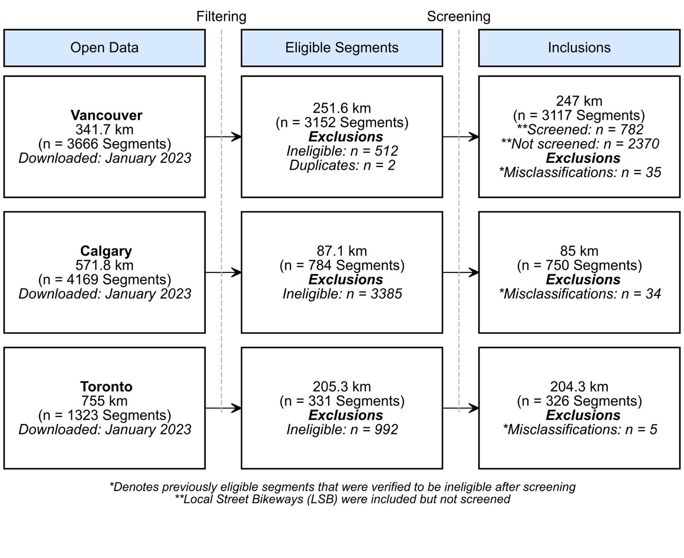

**Figure 1: Flow diagram of inclusion criteria for bikeway segments in Vancouver, Calgary, and Toronto**. This flowchart provides a high-level overview of the segment inclusions and exclusions for each municipality. Data from Calgary were specific to on-street routes only. For detailed flow diagrams specific to each municipality, please refer to the **Appendix**.

3.2 Objective 1: Verification

Installation years were verified for all segments, and showed that 66% of included segments in Vancouver, 8% in Calgary, and 41% in Toronto had dedicated cycling infrastructure established by 2009 or earlier. In Vancouver, among segments installed or updated during the study period, 83.3% accurately matched the city's provided installation years, and 97.2% were within a ±1-year range. For Calgary, a smaller subset of segments 42.1% matched with the city's recorded installation years, and 62.7% were accurate within ±1 year. Finally, in Toronto, among 188 eligible segments, 74.5% accurately matched with the city's provided installation years, and 78.2% were accurate within a ±1-year span.

When contrasting the classification of infrastructure between the verified and original (provided by each city) data, the verified data revealed slightly more painted lanes for Vancouver and Calgary, slightly less cycle tracks for Calgary and Toronto, and slightly more cycle tracks for Vancouver (***Table 2***). Toronto had the largest difference (+19 km) in painted lanes, while total on-street cycling infrastructure had smaller differences (+6.2, -1.4, and +19 km) between the verified and original data for Vancouver, Calgary, and Toronto respectively.

|  |  |  |  |  |
| --- | --- | --- | --- | --- |
| **City** | **Classification** | **Municipal** | **Verified** | **Difference** |
| **Vancouver** | Painted Lanes | 43.8 km | 46.7 km | +2.9 km (6.4%) |
| Cycle Tracks | 27.4 km | 30.7 km | +3.3 km (11.4%) |
| **On-Street Infrastructure, Total** | **71.2 km** | **77.4 km** | **+6.2 km (8.3%)** |
| **Calgary** | Painted Lanes | 57.0 km | 60.3 km | +3.3 km (5.6%) |
| Cycle Tracks | 31.7 km | 26.9 km | -4.8 km (16.4%) |
| **On-Street Infrastructure, Total** | **88.7 km** | **87.2 km** | **-1.5 km (1.7%)** |
| **Toronto** | Painted Lanes | 131.5 km | 151.4 km | +19.9 km (14.1%) |
| Cycle Tracks | 73.9 km | 73.0 km | -0.9 km (1.2%) |
| **On-Street Infrastructure, Total** | **205.4 km** | **224.4 km** | **+19.0 km (8.8%)** |

**Table 2: Comparison of Municipal Roadway Infrastructure and Verified Bikeway Infrastructure in Vancouver, Calgary and Toronto (Canada), 2022.** Painted lanes include buffered lanes. Verified bikeway lengths available in ***Appendix 1****.*

3.3 Objective 2.: Trends in infrastructure installation

There has been significant growth in dedicated on-street cycling infrastructure since 2009 across all three cities. In 2009, Vancouver, Calgary, and Toronto had approximately 19 km, 1 km, and 18 km of cycling infrastructure per 1000 km of total roadway, respectively. Local street bikeways made up more than half of Vancouver’s cycling infrastructure at about 75 km per 1000 cen-km of total roadway. By 2022, the dedicated on-street cycling infrastructure in Vancouver had approximately doubled (from 19.2 to 34.2 km per 1000 km of roadway); a rate of similar growth to Toronto (18.7 to 40.2 km per 1000 km of roadway). In Calgary, the cycling infrastructure had increased about eleven-fold from 2009 to 2022 (1.2 to 11 km per 1000 km of roadway). In 2009, only 4% of Vancouver's dedicated on-street cycling infrastructure were cycle tracks and none existed in Calgary or Toronto. This changed substantially by the end of the study period, with cycle tracks constituting 39.7% of Vancouver's, 30.9% of Calgary's, and 32.5% of Toronto's dedicated on-street cycling infrastructure (***Figure 2***). This increase in cycle tracks has partly been driven by upgrades of existing painted lane infrastructure(***Figure 3***). This is particularly salient in Vancouver, which has seen decreases in painted lanes since 2016, as these routes are upgraded to infrastructure that physically separates cyclists from traffic.

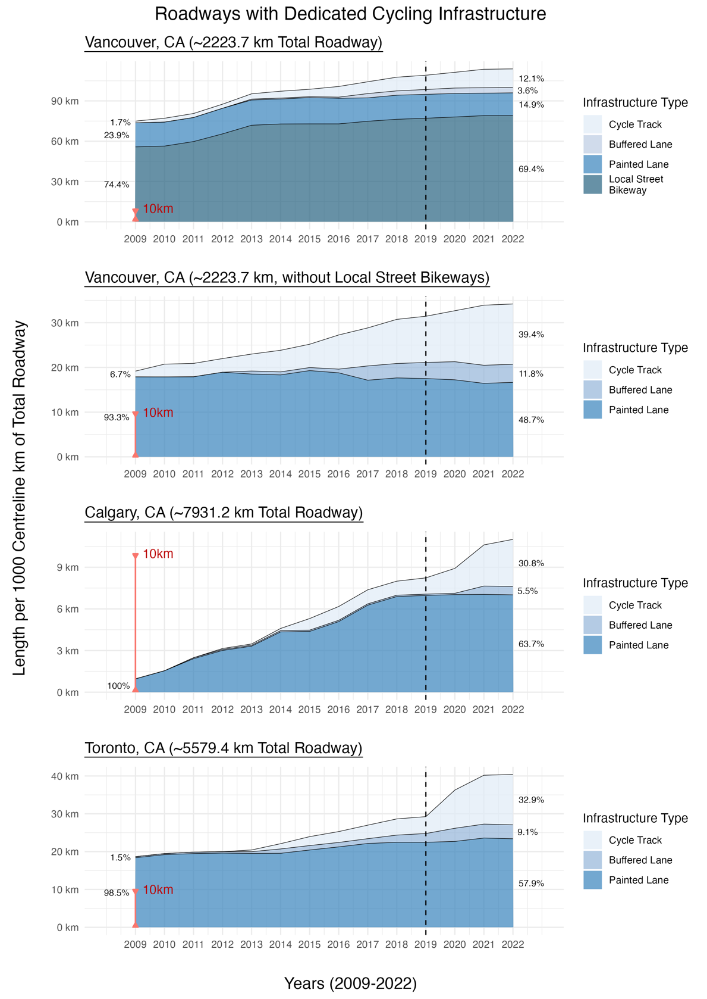

***Figure 2: Changes in dedicated cycling infrastructure between 2009 and 2022 for Vancouver, Calgary, and Toronto based by infrastructure category****. Assessed using roadway centreline-km, with infrastructure classifications determined by the most protective element present along each road segment.*

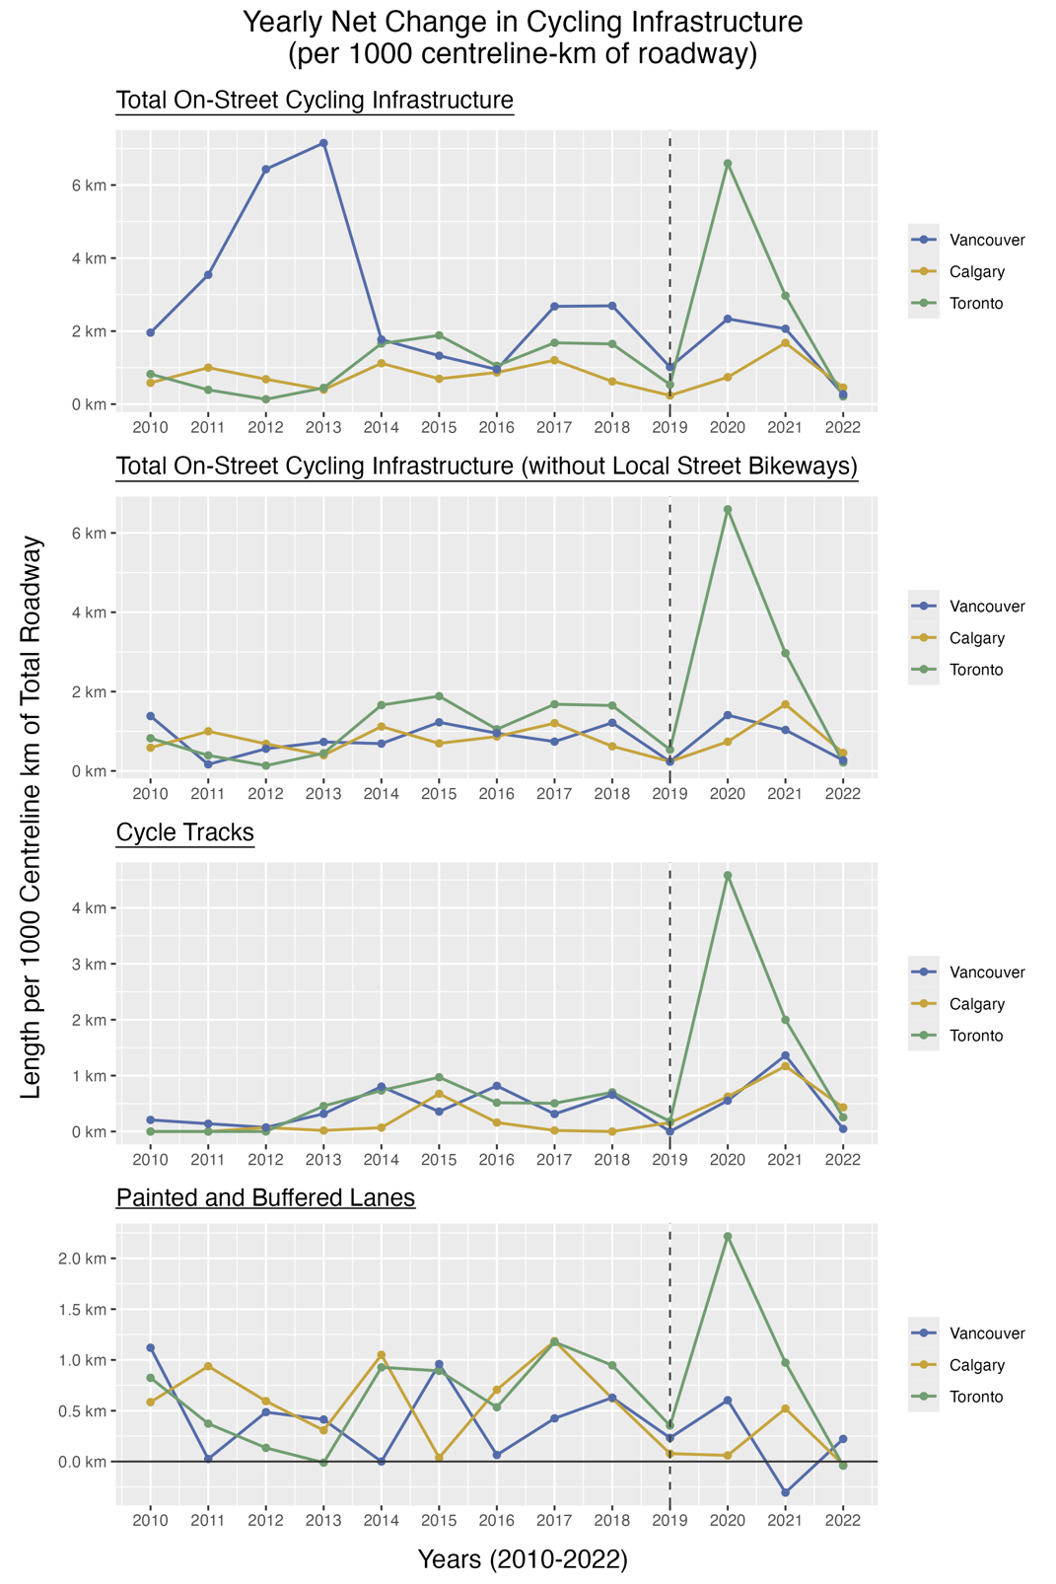

***Figure 3: Yearly net change in cycle route infrastructure by municipality, standardized per 1000 centerline-km of roadway.*** *The net change considers both the installation of new facilities, and the removal of existing infrastructure, such as when an existing facility is upgraded. Cycle route infrastructure is defined by the most protective element along a street centreline. This reflects the overall modifications made within each municipality over the course of the study period (2009-2022).*

As illustrated in ***Figure 3***, the growth in infrastructure in Toronto and Vancouver infrastructure peaked in 2020 at the onset of the COVID-19 pandemic, with over 6 km and 1 km of new infrastructure per 1000 cen-km of roadway installed respectively, while Calgary’s peak occurred in 2021, with over 1 km of new infrastructure built per 1000 cen-km of roadway. For Calgary and Toronto, this growth of on-street cycling infrastructure was primarily attributable to the increase in cycle tracks (***Figures 2 and 3)***.

Much of the increase in cycling infrastructure stemmed from the introduction of cycle tracks on arterial roads. As seen in **Supplementary Figures** 4 to 6, between 2019 to 2022, cen-km for cycle tracks increased by about 45%, 83% and 300% in Vancouver, Calgary, and Toronto respectively. In contrast, less attention has been given to building protected facilities on collector roads in Vancouver and Calgary (which showed lower than 40% increase in cen-km between 2019 to 2022 respectively), and local roads in Vancouver and Toronto, with less than 10% of local roads being cycle tracks between 2019 to 2022. These trends in collector and local roads were not only since the start of the pandemic, but throughout the entire study period.

In addition, a map of infrastructure – new and upgraded - following the onset of the pandemic is shown in ***Figure 4*** to identify areas of change and to examine the connectivity of cycline infrastructure. In Vancouver, 4% of the existing infrastructure was upgraded and 8% was newly installed in the downtown area, in the central area, and in the east and western borders. Calgary had less than 1% upgraded, while 23% was newly installed in and closer to the downtown area. Finally, in Toronto 9% of infrastructure was upgraded and 24% was newly installed mostly in the downtown area with some changes in the central and eastern areas.

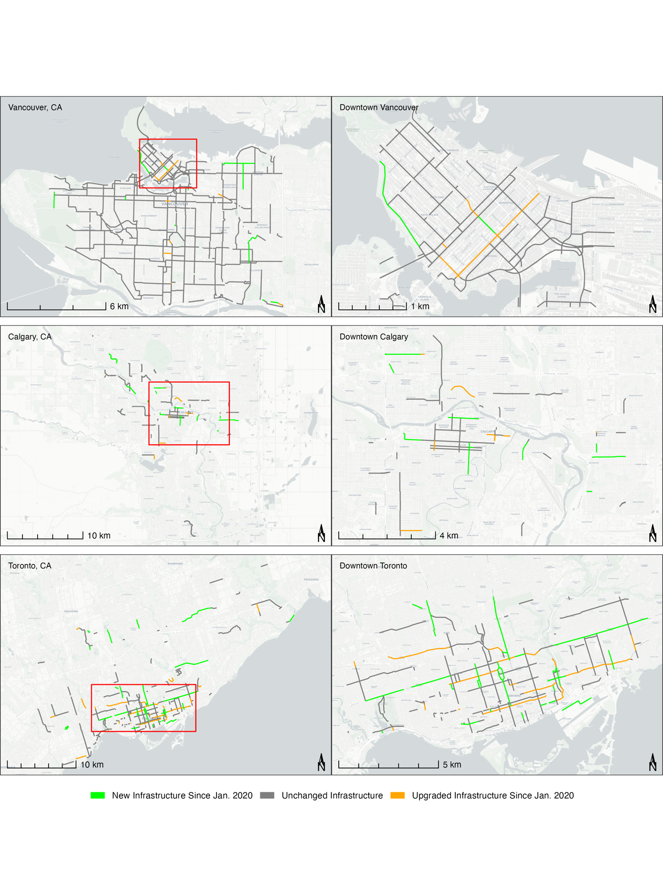

***Figure 4: Changes in Dedicated On-Street Infrastructure Since January 2020 for Vancouver, Calgary, and Toronto.*** *Basemap from OpenStreetMap and Carto (Positron).*

**DISCUSSION**

The objectives of this study were to compile and verify on-street cycling infrastructure data and describe the trends in the implementation this infrastructure across Vancouver, Calgary, and Toronto from 2009 to 2022. Our study used standardized criteria for classifying cycling infrastructure and leverage grey literature and street view imagery services for verification. Accurate data and tracking of trends is essential for continuee planning and evaluation for safe cycling infrastructure in major Canadian cities.

Overall discrepancies in classification were approximately 9% in Vancouver and Toronto; whereas Calgary’s classifications showed more accuracy with discrepancies under 2% . Issues related to consistent, up-to-date data related to cycling infrastructure have been noted before, but have been primarily related to inconsistent classification and not the accuracy of installation dates (24–26). Our study portrays that municipal records in cities in Canada frequently do not accurately report when cycling infrastructure is implemented or upgraded or the type of infrastructure that is actually present on the roadway. It is important to consider data accuracy in other municipalities when evaluating infrastructure changes.

We found a consistent growth of the cycling network occurred in all three cities over the time period, with a shift towards protected cycling infrastructure with approximately 1/3 of all infrastructure being protected cycle tracks in all cities by the end of the study period. Toronto and Vancouver’s overall expansions of approximately two-fold over the study period was exceeded by Calgary’s eleven-fold expansion. This may be explained by the fact that Calgary had much less cycling infrastructure prior to the pandemic in 2019 as compared to the other two cities. Toronto’s peak occurred in 2020, when council approved the ActiveTO plan, to provide more space for pedestrian and cycling to facilitate physical activity that was necessary during the pandemic (44). ActiveTO, included the largest one-year expansion of on-street bike lanes in 2020 (45). The increase in cycling infrastructure after the start of the pandemic found in our study has also been demonstrated in other cities around the world (46–49). Buehler and Pucher review of cycling research after COVID-19 (March 2020-January 2023) (50) and found that expansions or bikeway network improvements accelerated during the pandemic, with a focus on protected bike lanes, traffic calming, slow streets and car-free streets.

Calgary’s infrastructure implementation peaked also after the start of pandemic in 2021, with a significant increase in separated infrastructure (51). In 2021, two major policy changes occurred in Calgary that may have contributed to an increase focus on cycling infrastructure, and likely influenced by the increased perceived importance of safe active transportation during the pandemic; the Calgary Transportation Plan was adapted to include Network maps and network principles for safe and comfortable walking and wheeling (51). In addition, the City of Calgary adopted 40 km/h residential speed limits, which included a policy change to update roadway design standards to achieve safer active transportation (51). Vancouver, although having a slight peak in cycle track installations after the start of the pandemic, its biggest peak was evident in 2012 - 2013 with its Transportation 2040 plan in which walking and cycling were identified as the highest transportation priorities (52,53).

It is important to continue the type of roadways cycling infrastructure is being located on. Chas been infrastructure has been ly distributed has .

Our study, in the Canadian context, offers valuable insights into cycling infrastructure implementation trends, with key strengths including the use of standardized criteria for classifying infrastructure and an innovative visual approach to confirm changes over time, as opposed to relying on municipal reports (which may be unreliable). Limitations of our study related to the classification of infrastructure and data availability. By defining infrastructure based on the most protective infrastructure, some finer details regarding infrastructure modifications may have been overlooked. Additionally, the exclusion of temporary infrastructure could have resulted in some selection bias in terms of the areas of the cities where temporary versus permanent infrastructure were located and may have limited the study's ability to fully capture how municipalities promoted active transportation, particularly during the pandemic. However, this study accurately reflects the permanent infrastructure that each city has installed to promote longer term cycling, after the start of the pandemic. Finally, given that each city updates data at different times, some relevant data may not have been captured at the time of data acquisition in January and May of 2023, thus there is a possibility that we did not fully capture all infrastructure from the start to end of 2022. This may explain the small changes in infrastructure from 2021 to 2022.

Overall, the expansion of on-street cycling infrastructure over the past decade is a reflection of the growing popularity of cycling as a mode of transportation (44), and investments in infrastructure having played a key role in supporting this upward trend (45). The insights from this study also set the stage for more in-depth research into cycling infrastructure trends, particularly as they relate to road safety and equity. Identifying how municipalities have responded to existing gaps in cycling networks, particularly in relation to factors such as population density and neighbourhood marginalization, is important to promote healthy and equitable mobility for all. This detailed exploration helps shed light on these factors in urban planning and may contribute to a better understanding of how cycling infrastructure is prioritized and implemented across municipalities.

**CONCLUSIONS**

In summary, this comprehensive evaluation of on-street cycling infrastructure trends in Vancouver, Calgary, and Toronto from 2009 to 2022 provides insight into how municipalities have responded to an increased demand for permanent and safe cycling infrastructure. The study shows an expansion in dedicated cycling networks, particularly in the form of cycle tracks, reflecting a conscious shift toward safer and more “comfortable” cycling facilities. The COVID-19 pandemic has notably spurred an upward trend in infrastructure development in response to changing mobility patterns and evolving public health needs. These trends may indicate a larger paradigm shift, reflecting efforts to embrace active transportation and to rethink the design of urban centers (54). Discrepancies and misclassifications within municipal cycling network data and the poor reliability of infrastructure implementation dates points to the fact that these data are not collected for the purpose of evaluation or research. This underscores the need for standardized classifications for infrastructure and accurate implementation data to facilitate effective urban planning and policymaking. Despite some progress, the findings also point to a need for continued investment to address disconnected cycling networks, particularly as protected facilities were often less common along medium-traffic collector roads. By investing in more inclusive and connected cycling networks that align with the Vision Zero road safety plan, municipalities can foster safer, more sustainable, and resilient mobility in cities.

**REFERENCES:**

1. Gordon C. Economic benefits of active transportation. In: *Children’s Active Transportation*. Elsevier; 2018 (Accessed September 17, 2024):39–52.(https://www.sciencedirect.com/science/article/pii/B978012811931000003X). (Accessed September 17, 2024)

2. Pucher J, Buehler R. Cycling towards a more sustainable transport future. *Transport Reviews*. 2017;37(6):689–694.

3. Brand C, Dons E, Anaya-Boig E, et al. The climate change mitigation effects of daily active travel in cities. *Transportation Research Part D: Transport and Environment*. 2021;93:102764.

4. Pucher J, Dill J, Handy S. Infrastructure, programs, and policies to increase bicycling: an international review. *Preventive Medicine*. 2010;50:S106–S125.

5. Pucher J, Buehler R. Sustainable transport in Canadian cities: cycling trends and policies. *Berkeley Planning Journal* [electronic article]. 2006;19(1). (https://escholarship.org/uc/item/0rr0t06s). (Accessed May 26, 2024)

6. Cowle S, Fuselli P, Rajabali F, et al. The cost of transport injuries in Canada. Sudbury, Ontario: The Canadian Association of Road Safety Professionals; 2022 (Accessed September 17, 2024):1–7.(https://carsp.ca/en/presentations-and-papers/carsp-hybrid-conference-sudbury-2022/the-cost-of-transport-injuries-in-canada-2/). (Accessed September 17, 2024)

7. Toronto Police Service. Cyclists KSI collisions. 2023;(https://data.torontopolice.on.ca/pages/cyclists). (Accessed May 26, 2024)

8. Toronto Public Health. Road to health: improving walking and cycling in Toronto. 2012.

9. Parachute. Cost of injury in canada the highest costs: falls and transport. *Parachute*. 2022;(https://parachute.ca/the-highest-costs-falls-and-transport/)

10. Aboelata M, Yanez E, Kharrazi R. Vision Zero: a health equity road map for getting to zero in every community. *Prevention Institute*. 2017;1–11.

11. Parachute. Vision Zero map. 2023;(https://parachute.ca/en/program/vision-zero/vision-zero-map/). (Accessed July 22, 2024)

12. Belin M-Å, Tillgren P, Vedung E. Vision Zero – a road safety policy innovation. *International Journal of Injury Control and Safety Promotion*. 2012;19(2):171–179.

13. City of Toronto. Vision Zero emphasis areas. *City of Toronto*. 2017;(https://www.toronto.ca/services-payments/streets-parking-transportation/road-safety/vision-zero/emphasis-areas/). (Accessed October 27, 2024)

14. City of Vancouver. Transportation design guidelines: all ages and abilities cycling routes. 2017;(https://vancouver.ca/files/cov/design-guidelines-for-all-ages-and-abilities-cycling-routes.pdf)

15. Transportation Association of Canada. Geometric design guide for Canadian roads: chapter 5 – bicycle integrated design (2017). 2017 (Accessed September 20, 2024).(https://www.tac-atc.ca/en/knowledge-centre/technical-resources-search/publications/ptm-geodes5-e/). (Accessed September 20, 2024)

16. Ministry of Transportation and Infrastructure. Active transportation design guide - province of British Columbia. Province of British Columbia; 2019 (Accessed September 20, 2024).(https://www2.gov.bc.ca/gov/content/transportation/transportation-infrastructure/engineering-standards-guidelines/traffic-engineering-safety/active-transportation-design-guide). (Accessed September 20, 2024)

17. Winters M, Zanotto M, Butler G. At-a-glance-the Canadian bikeway comfort and safety (CAN-BICS) classification system: a common naming convention for cycling infrastructure. *Health Promotion and Chronic Disease Prevention in Canada: Research, Policy and Practice*. 2020;40(9):288.

18. Gössling S, McRae S. Subjectively safe cycling infrastructure: new insights for urban designs. *Journal of Transport Geography*. 2022;101:103340.

19. Fischer J, Winters M. COVID-19 street reallocation in mid-sized Canadian cities: socio-spatial equity patterns. *Can J Public Health*. 2021;112(3):376–390.

20. Canadian Institute for Health Information. Injury and trauma emergency department and hospitalization statistics, 2020–2021. 2022;(https://www.cihi.ca/sites/default/files/document/injury-trauma-emergency-dept-hospitalizations-2020-2021-data-tables-en.xlsx). (Accessed April 26, 2023)

21. Canadian Institute for Health Information. National ambulatory care reporting system metadata (NACRS). 2023;(www.cihi.ca/en/national-ambulatory-care-reporting-system-metadata-nacrs). (Accessed April 27, 2023)

22. Batomen B, Macpherson A, Lewis J, et al. Vulnerable road user injury trends following the COVID-19 pandemic in Toronto, Canada: an interrupted time series analysis. *Journal of Safety Research*. 2024;89:152–159.

23. Batomen B, Cloutier M-S, Palm M, et al. Frequent public transit users views and attitudes toward cycling in Canada in the context of the COVID-19 pandemic. *Multimodal Transportation*. 2023;2(2):100067.

24. Ferster C, Fischer J, Manaugh K, et al. Using OpenStreetMap to inventory bicycle infrastructure: A comparison with open data from cities. *International Journal of Sustainable Transportation*. 2020;14(1):64–73.

25. Ferster C, Nelson T, Manaugh K, et al. Developing a national dataset of bicycle infrastructure for Canada using open data sources. *Environment and Planning B: Urban Analytics and City Science*. 2023;50(9):2543–2559.

26. Winters M, Beairsto J, Ferster C, et al. The Canadian bikeway comfort and safety metrics (CAN-BICS): national measures of the bicycling environment for use in research and policy. *Health Reports*. 2022;33(10):3–13.

27. Nelson T, Ferster C, Laberee K, et al. Crowdsourced data for bicycling research and practice. *Transport Reviews*. 2021;41(1):97–114.

28. Teschke K, Harris MA, Reynolds CCO, et al. Route infrastructure and the risk of injuries to bicyclists: a case-crossover study. *Am J Public Health*. 2012;102(12):2336–2343.

29. Boss D, Nelson T, Winters M. Monitoring city wide patterns of cycling safety. *Accident Analysis & Prevention*. 2018;111:101–108.

30. Ravensbergen L, Buliung R, Laliberté N. Fear of cycling: social, spatial, and temporal dimensions. *Journal of Transport Geography*. 2020;87:102813.

31. Zhao Q, Winters M, Nelson T, et al. Who has access to cycling infrastructure in Canada? A social equity analysis. *Computers, Environment and Urban Systems*. 2024;110:102109.

32. Winters M, Branion-Calles M, Therrien S, et al. Impacts of bicycle infrastructure in mid-sized cities (IBIMS): protocol for a natural experiment study in three Canadian cities. *BMJ Open*. 2018;8(1):e019130.

33. Tabascio A, Tiznado-Aitken I, Harris D, et al. Assessing the potential of cycling growth in Toronto, Canada. *International Journal of Sustainable Transportation*. 2023;17(12):1370–1383.

34. Branion-Calles M, Nelson T, Fuller D, et al. Associations between individual characteristics, availability of bicycle infrastructure, and city-wide safety perceptions of bicycling: A cross-sectional survey of bicyclists in 6 Canadian and U.S. cities. *Transportation Research Part A: Policy and Practice*. 2019;123:229–239.

35. Berghoefer FL, Vollrath M. Prefer what you like? Evaluation and preference of cycling infrastructures in a bicycle simulator. *Journal of Safety Research*. 2023;87:157–167.

36. Assunçao-Denis M-È, Tomalty R. Increasing cycling for transportation in Canadian communities: understanding what works. *Transportation Research Part A: Policy and Practice*. 2019;123:288–304.

37. Orvin MM, Fatmi MR, Chowdhury S. Taking another look at cycling demand modeling: A comparison between two cities in Canada and New Zealand. *Journal of Transport Geography*. 2021;97:103220.

38. City of Toronto. Cycling network. *Open Data Portal*. 2023;(https://open.toronto.ca/dataset/). (Accessed January 1, 2023)

39. City of Vancouver. Bikeways. *Open Data Portal*. 2023;(https://opendata.vancouver.ca/explore/dataset/bikeways/information). (Accessed January 1, 2023)

40. City of Calgary. Calgary bikeways. *Open Data Portal*. 2023;(https://data.calgary.ca/Transportation-Transit/Calgary-Bikeways/jjqk-9b73). (Accessed January 1, 2023)

41. Nolan J, Sinclair J, Savage J. Are bicycle lanes effective? The relationship between passing distance and road characteristics. *Accident Analysis & Prevention*. 2021;159:106184.

42. R Core Team. R: a language and environment for statistical computing. 2023;(https://www.r-project.org/). (Accessed September 17, 2024)

43. Pebesma E, Bivand R, Racine E, et al. sf: simple features for r. 2024;(https://cran.r-project.org/package=sf). (Accessed May 16, 2024)

44. City of Toronto. ActiveTO. *City of Toronto*. 2020;(https://www.toronto.ca/explore-enjoy/parks-recreation/activeto/). (Accessed October 28, 2024)

45. City of Toronto. ActiveTO - expanding the cycling network. *City of Toronto*. 2020;(https://www.toronto.ca/explore-enjoy/parks-recreation/activeto/activeto-expanding-the-cycling-network/). (Accessed October 28, 2024)

46. Kraus S, Koch N. Provisional COVID-19 infrastructure induces large, rapid increases in cycling. *Proc. Natl. Acad. Sci. U.S.A.* 2021;118(15):e2024399118.

47. Sunio V, Mateo-Babiano I. Pandemics as ‘windows of opportunity’: transitioning towards more sustainable and resilient transport systems. *Transport Policy*. 2022;116:175–187.

48. Rérat P, Haldimann L, Widmer H. Cycling in the era of Covid-19: the effects of the pandemic and pop-up cycle lanes on cycling practices. *Transportation Research Interdisciplinary Perspectives*. 2022;15:100677.

49. Buehler R, Pucher J. Cycling through the COVID-19 pandemic to a more sustainable transport future: evidence from case studies of 14 large bicycle-friendly cities in Europe and North America. *Sustainability*. 2022;14(12):7293.

50. Buehler R, Pucher J. COVID-19 and cycling: a review of the literature on changes in cycling levels and government policies from 2019 to 2022. *Transport Reviews*. 2024;44(2):299–344.

51. Bike Calgary. Calgary cycling infrastructure – 2021 year in review. *Bike Calgary*. 2022;(https://bikecalgary.org/calgary-cycling-infrastructure-2021-year-in-review/). (Accessed October 28, 2024)

52. City of Vancouver. Transportation 2040. 2012 (Accessed October 28, 2024).(https://vancouver.ca/files/cov/Transportation_2040_Plan_as_adopted_by_Council.pdf). (Accessed October 28, 2024)

53. City of Vancouver. Transportation 2040 - 2013 active transportation corridor implementation. 2013 (Accessed October 28, 2024).(https://council.vancouver.ca/20130612/documents/cfsc2.pdf). (Accessed October 28, 2024)

54. Nikitas A, Tsigdinos S, Karolemeas C, et al. Cycling in the era of COVID-19: lessons learnt and best practice policy recommendations for a more bike-centric future. *Sustainability*. 2021;13(9):4620.

**APPENDIX 1 – SUPPLEMENTARY RESULTS**

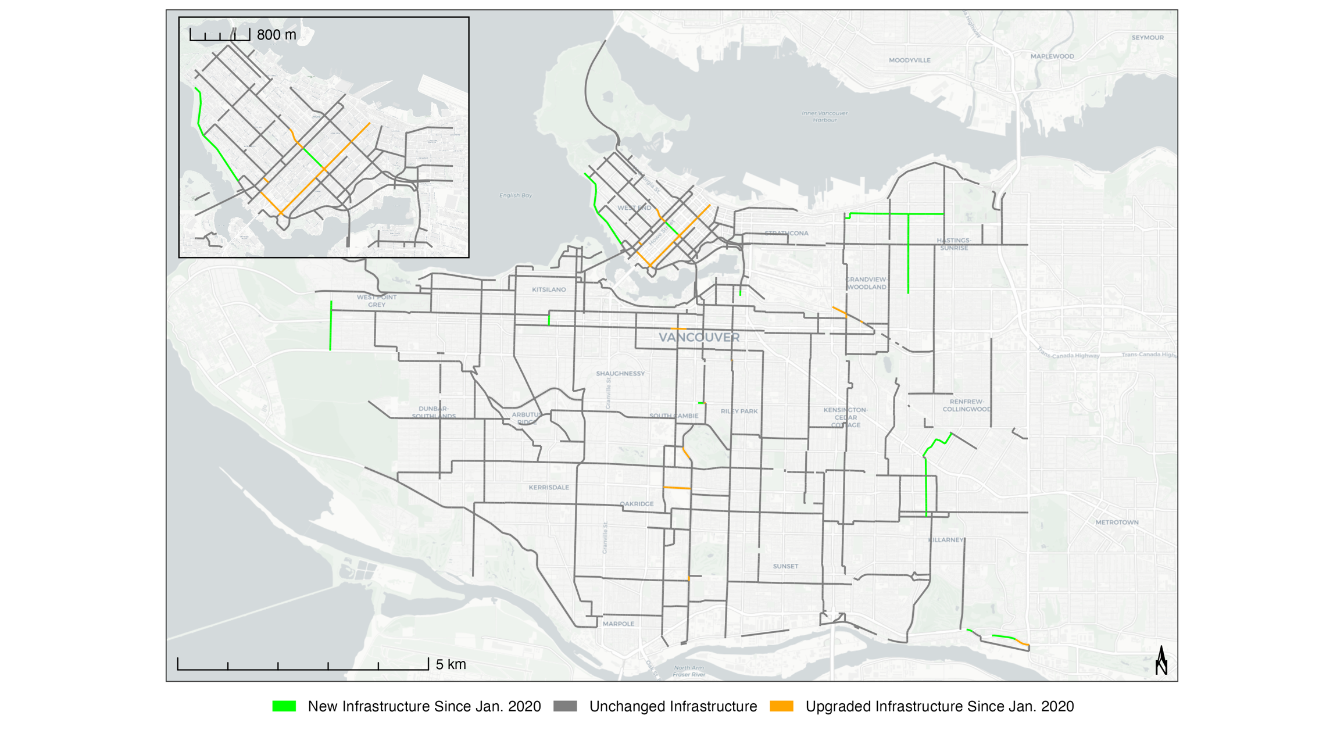

***Supplementary Figure 1: Enlarged Map. Changes in Dedicated On-Street Cycling Infrastructure Between 2020-2021 for the Municipality of Vancouver, CA.*** *New installations of dedicated infrastructure are denoted in green, upgrades from a previous dedicated infrastructure type are denoted in orange. Basemap from OpenStreetMap and Carto (Positron).*

**

***Supplementary Figure 2: Enlarged Map. Changes in Dedicated On-Street Cycling Infrastructure Between 2020-2022 for the Municipality of Calgary, CA.*** *New installations of dedicated infrastructure are denoted in green, upgrades of dedicated infrastructure are denoted in orange. Basemap from OpenStreetMap and Carto (Positron).*

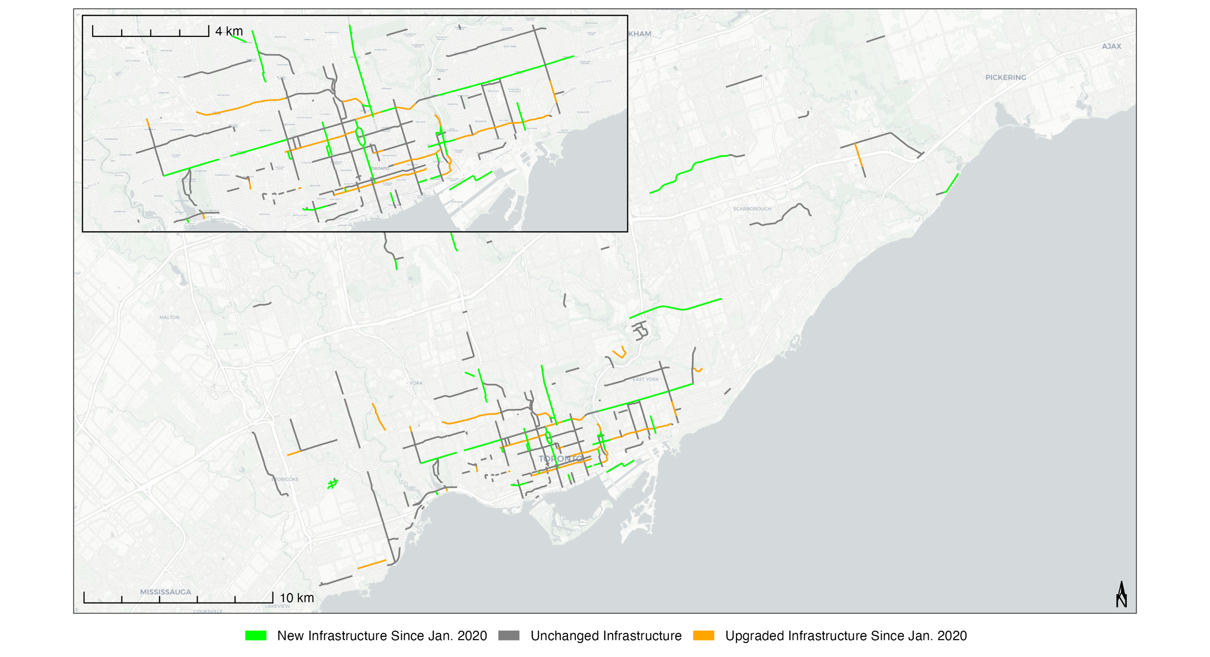

***Supplementary Figure 3: Enlarged Map. Changes in Dedicated On-Street Infrastructure Between 2020-2022 for the Municipality of Toronto, CA.*** *New installations of dedicated infrastructure are denoted in green, upgrades of dedicated infrastructure are denoted in orange. Basemap from OpenStreetMap and Carto (Positron).*

|  |  |  |  |  |  |  |  |  |  |  |  |  |  |  |  |
| --- | --- | --- | --- | --- | --- | --- | --- | --- | --- | --- | --- | --- | --- | --- | --- |
|  | **Total Length of Roadways with Dedicated Cycling Infrastructure by Year (2009-2022)**  *Measured by centreline-km of roadway* | | | | | | | | | | | | | | |
| **Vancouver** | | | | | **Calgary** | | | |  | **Toronto** | | | |  |
| Year | PL | BUF | CT | **TOTAL** | Change | PL | BUF | CT | **TOTAL** | Change | PL | BUF | CT | **TOTAL** | Change |
| 2009 | 39.80 | 0.00 | 2.84 | **42.64** |  | 7.62 | 0.00 | 0.00 | **7.62** |  | 102.57 | 1.56 | 0.00 | **104.13** |  |
| 2010 | 39.78 | 0.00 | 6.33 | **46.11** | 3.47 | 12.26 | 0.00 | 0.00 | **12.26** | 4.64 | 107.17 | 1.56 | 0.00 | **108.73** | 4.60 |
| 2011 | 39.84 | 0.00 | 6.64 | **46.48** | 0.37 | 19.15 | 0.55 | 0.00 | **19.70** | 7.44 | 108.72 | 2.08 | 0.00 | **110.80** | 2.07 |
| 2012 | 42.41 | 0.00 | 6.80 | **49.21** | 2.73 | 23.86 | 0.55 | 0.56 | **24.97** | 5.27 | 109.47 | 2.08 | 0.00 | **111.55** | 0.75 |
| 2013 | 41.82 | 1.50 | 8.76 | **52.08** | 2.87 | 26.30 | 0.55 | 0.70 | **27.55** | 2.58 | 108.95 | 2.54 | 2.55 | **114.04** | 2.49 |
| 2014 | 41.41 | 1.50 | 11.37 | **54.28** | 2.20 | 34.45 | 0.73 | 1.25 | **36.43** | 8.88 | 109.13 | 6.42 | 7.75 | **123.30** | 9.26 |
| 2015 | 43.54 | 1.50 | 12.30 | **57.34** | 3.06 | 34.75 | 0.73 | 6.61 | **42.09** | 5.66 | 113.99 | 6.55 | 13.16 | **133.70** | 10.40 |
| 2016 | 42.43 | 1.85 | 17.66 | **61.94** | 4.60 | 40.33 | 0.74 | 7.88 | **48.95** | 6.86 | 118.57 | 6.55 | 16.03 | **141.15** | 7.45 |
| 2017 | 38.77 | 7.09 | 19.60 | **65.46** | 3.52 | 49.73 | 0.74 | 8.03 | **58.50** | 9.55 | 123.60 | 6.55 | 19.44 | **149.59** | 8.44 |
| 2018 | 39.90 | 7.18 | 22.63 | **69.71** | 4.25 | 54.66 | 0.74 | 8.03 | **63.43** | 4.93 | 126.08 | 10.08 | 22.62 | **158.78** | 9.19 |
| 2019 | 39.59 | 8.00 | 23.67 | **71.26** | 1.55 | 55.28 | 0.74 | 9.28 | **65.30** | 1.87 | 126.07 | 12.45 | 23.63 | **162.15** | 3.37 |
| 2020 | 38.96 | 9.00 | 26.04 | **74.00** | 2.74 | 55.76 | 0.74 | 14.23 | **70.73** | 5.43 | 127.38 | 18.85 | 55.11 | **201.34** | 39.19 |
| 2021 | 37.19 | 9.00 | 30.58 | **76.77** | 2.77 | 55.87 | 4.76 | 23.50 | **84.13** | 13.40 | 132.35 | 20.03 | 70.82 | **223.20** | 21.86 |
| 2022 | 37.69 | 9.00 | 30.68 | **77.37** | 0.60 | 55.58 | 4.76 | 26.93 | **87.27** | 3.14 | 131.34 | 20.03 | 73.01 | **224.38** | 1.18 |

***Supplementary Table 1: Total Length of Dedicated On-Street Cycling Infrastructure between 2009 and 2022, for Vancouver, Calgary, and Toronto (Canada).*** *Each entry denotes the aggregated length of infrastructure existing at the conclusion the calendar year. Lengths are measured in roadway centreline-km, with cycling infrastructure classified according to the side of the road featuring the most protective element. Rows noted in light red denote infrastructure changes following the start of the COVID-19 pandemic. Geodesic lengths calculated in ArcGIS Pro 3.0.1.*

**

***Supplementary Figure 4: Changes in dedicated cycling infrastructure between 2009 and 2022 for the Municipality of Vancouver, CA*** *by (A) roadway classification, and (B) infrastructure distribution within each road class. Assessed using roadway centreline-km, with infrastructure classification determined by the most protective element present along each road segment.*

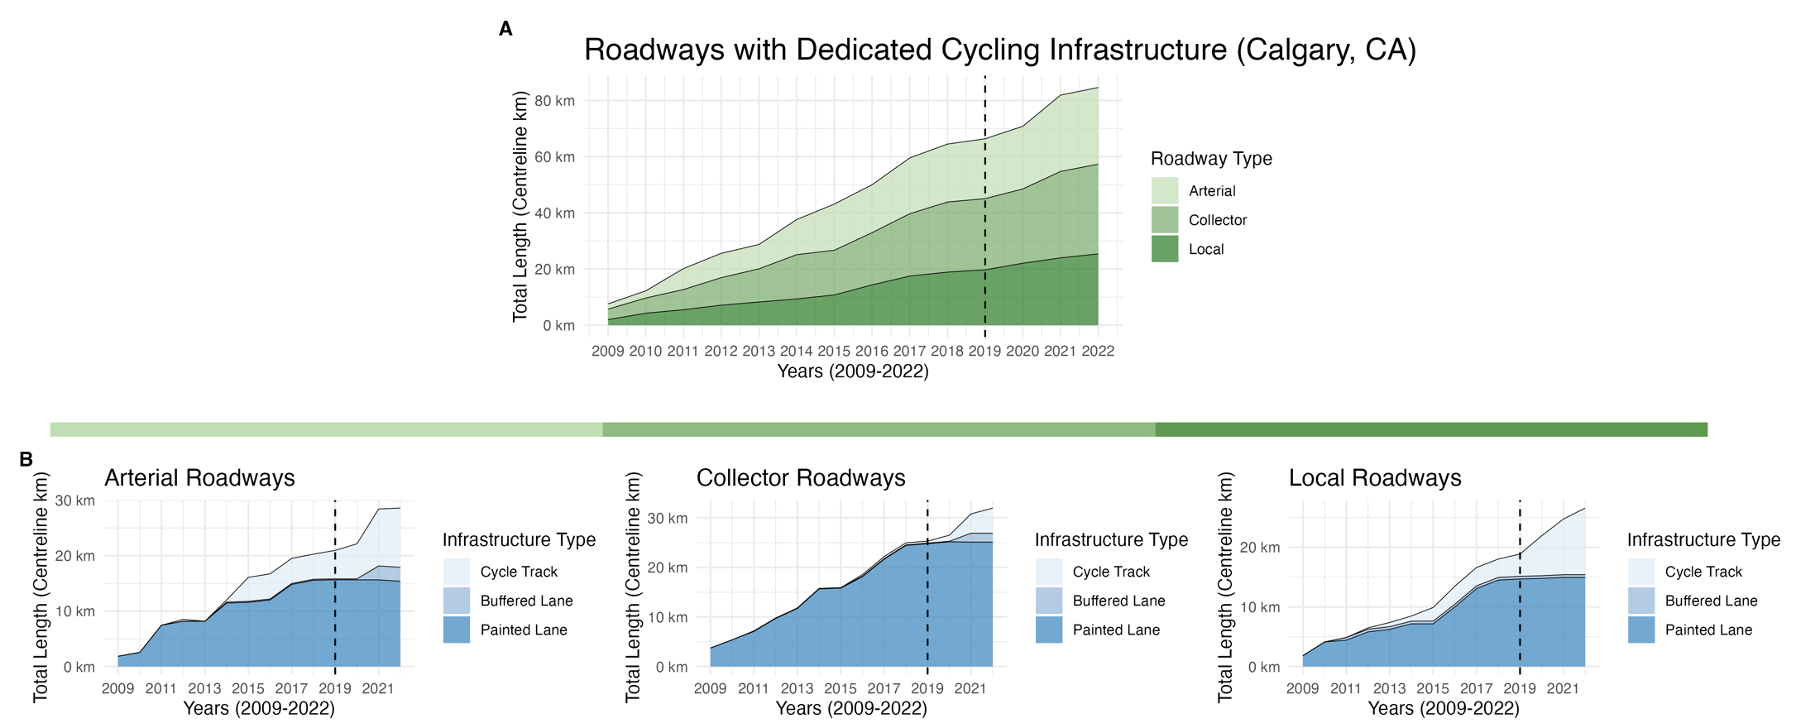

***Supplementary Figure 5: Changes in dedicated cycling infrastructure between 2009 and 2022 for the Municipality of Calgary, CA*** *by (A) roadway classification, and (B) infrastructure distribution within each road class. Assessed using roadway centreline-km, with infrastructure classification determined by the most protective element present along each road segment.*

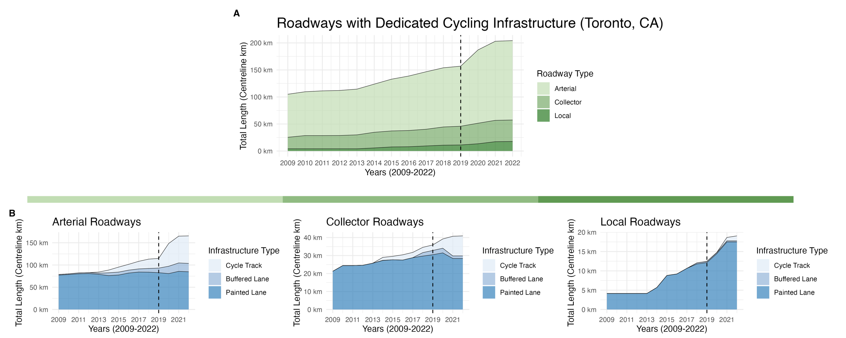

***Supplementary Figure 6: Changes in dedicated cycling infrastructure between 2009 and 2022 for the Municipality of Toronto, CA*** *by (A) roadway classification, and (B) infrastructure distribution within each road class. Assessed using roadway centreline-km, with infrastructure classification determined by the most protective element present along each road segment.*

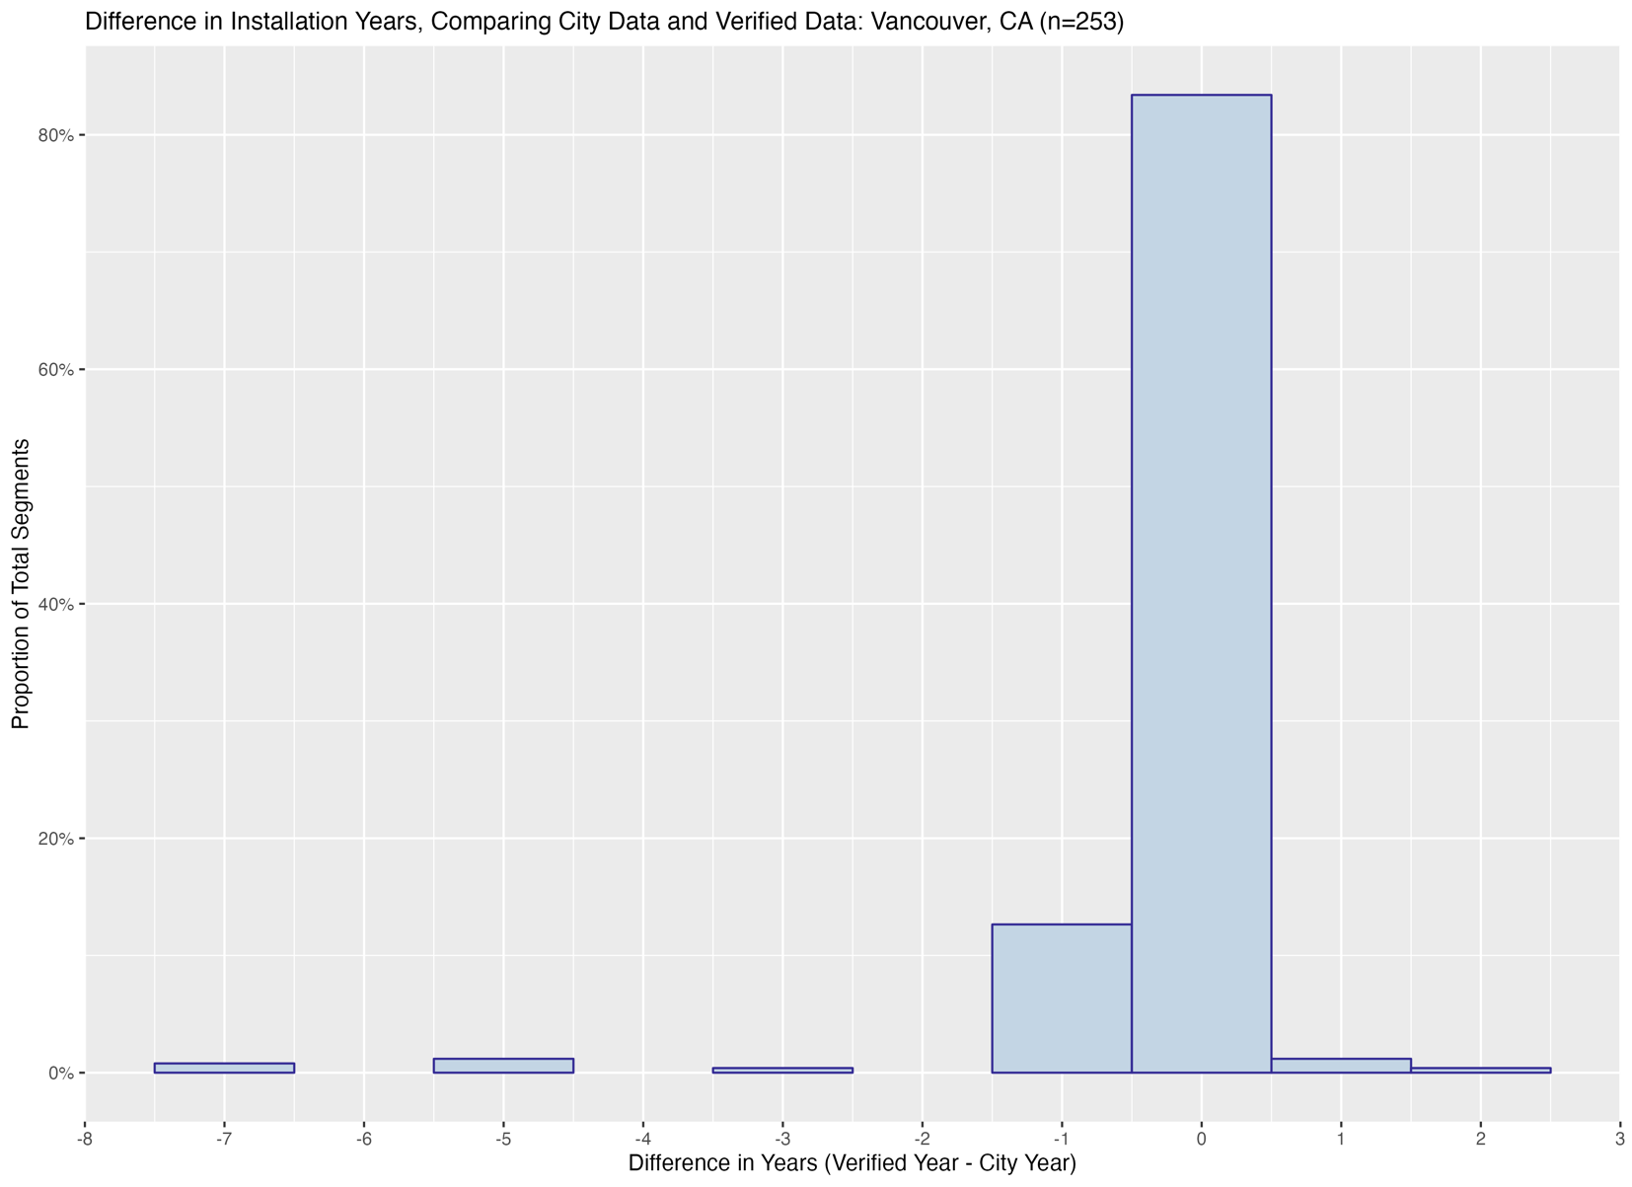

***Supplementary Figure 7: A comparative analysis between municipal data and verified data on the installation years for cycling infrastructure in Vancouver, CA.*** *Any data where a city provided and verified installation years were missing or the verified year occurred earlier or equal to the start of the study period (2009) has been excluded from analysis, yielding n=251 segments. The graph shows that 83.3% of the included segments had the correct installation year as per the city’s data, and 97.2% were accurate within a range of ±1 year.*

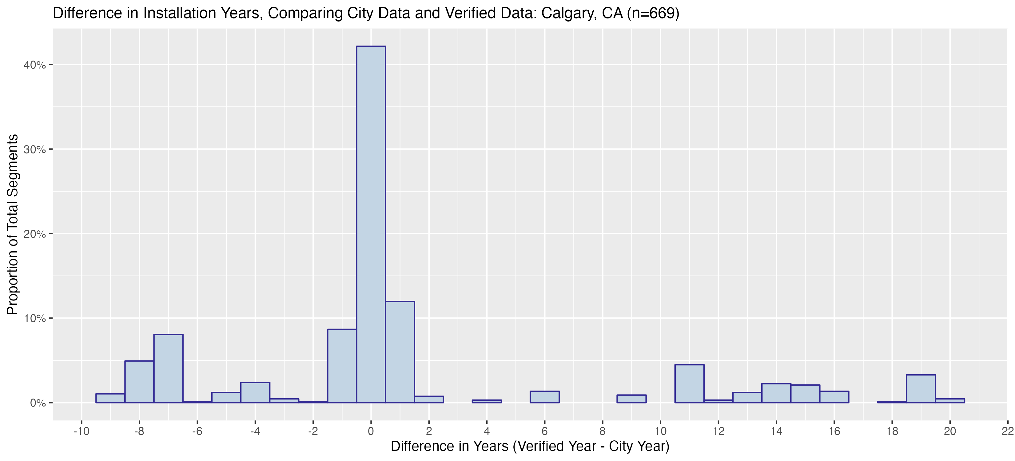

***Supplementary Figure 8: A comparative analysis between municipal data and verified data on the installation years for cycling infrastructure in Calgary, CA.*** *Any data where a city provided and verified installation years were missing or the verified year occurred earlier or equal to the start of the study period (2009) has been excluded from analysis, yielding n=668 segments. The graph shows that 42.1% of the included segments had the correct installation year as per the city’s data, and 62.7% were accurate within a range of ±1 year.*

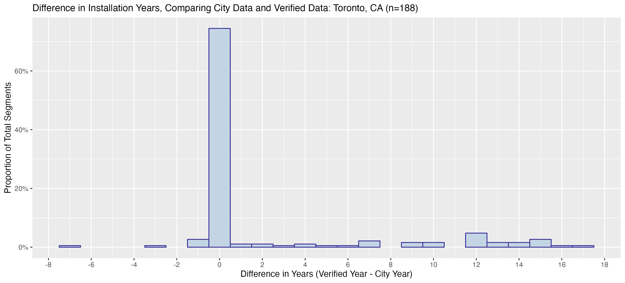

***Supplementary Figure 9: A comparative analysis between municipal data and verified data on the installation years for cycling infrastructure in Toronto, CA.*** *Any data where a city provided and verified installation years were missing or the verified year occurred earlier or equal to the start of the study period (2009) has been excluded from analysis, yielding n=188 segments. The graph shows that 74.5% of the included segments had the correct installation year as per the city’s data, and 78.2% were accurate within a range of ±1 year.*

**APPENDIX 2 – METHODOLOGY**

**Segment Inclusion Criteria for Vancouver**

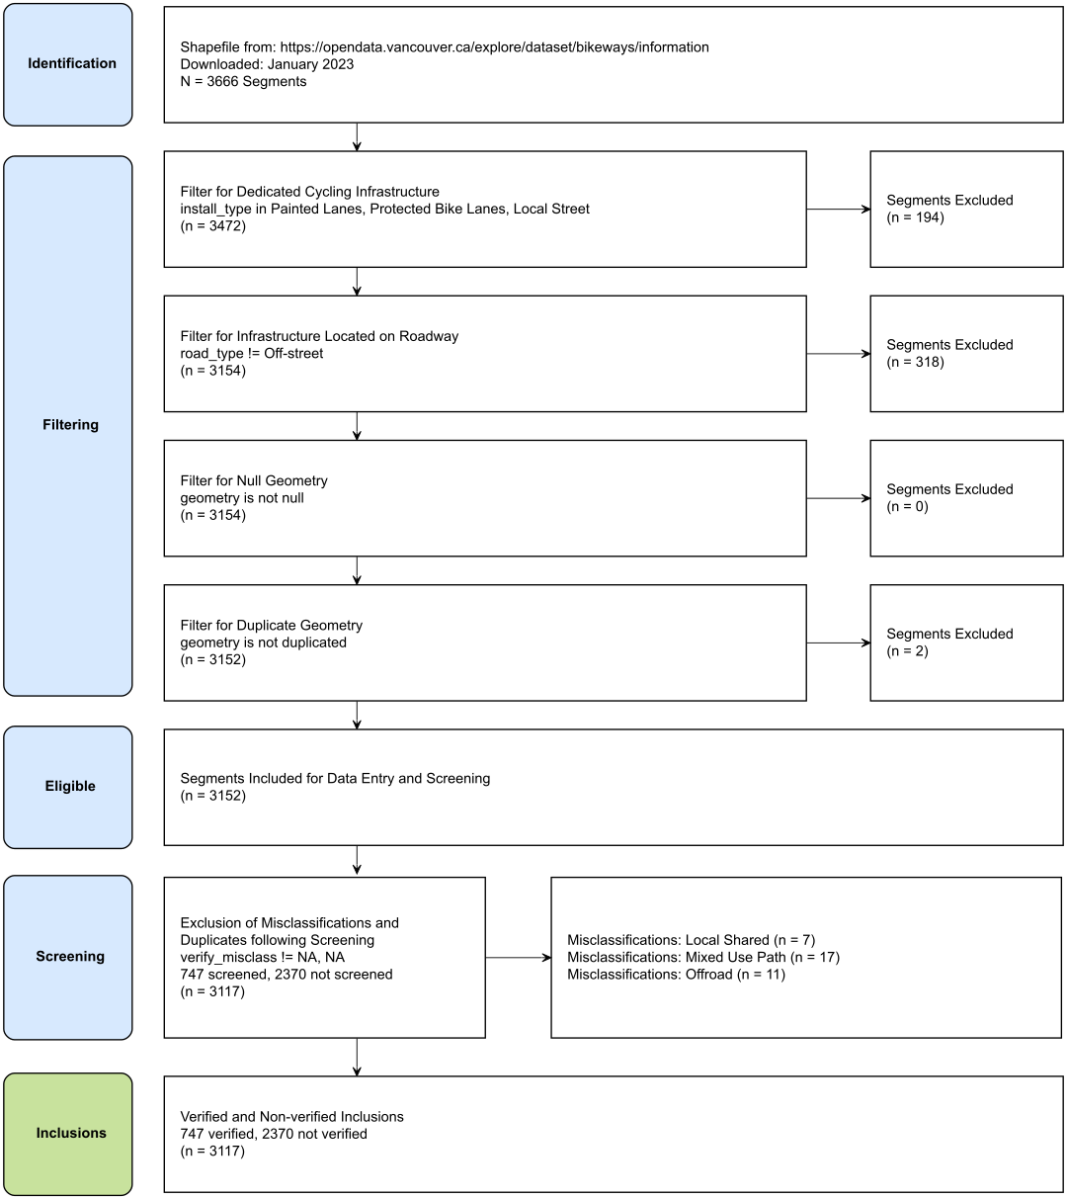

**Segment Inclusion Criteria for Calgary**

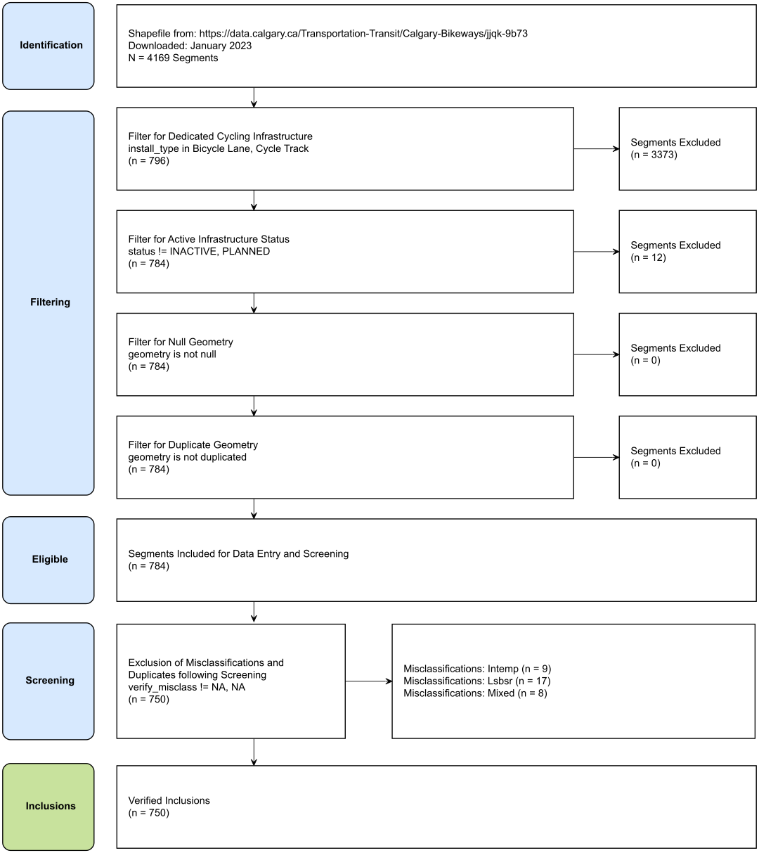

**Segment Inclusion Criteria for Toronto**

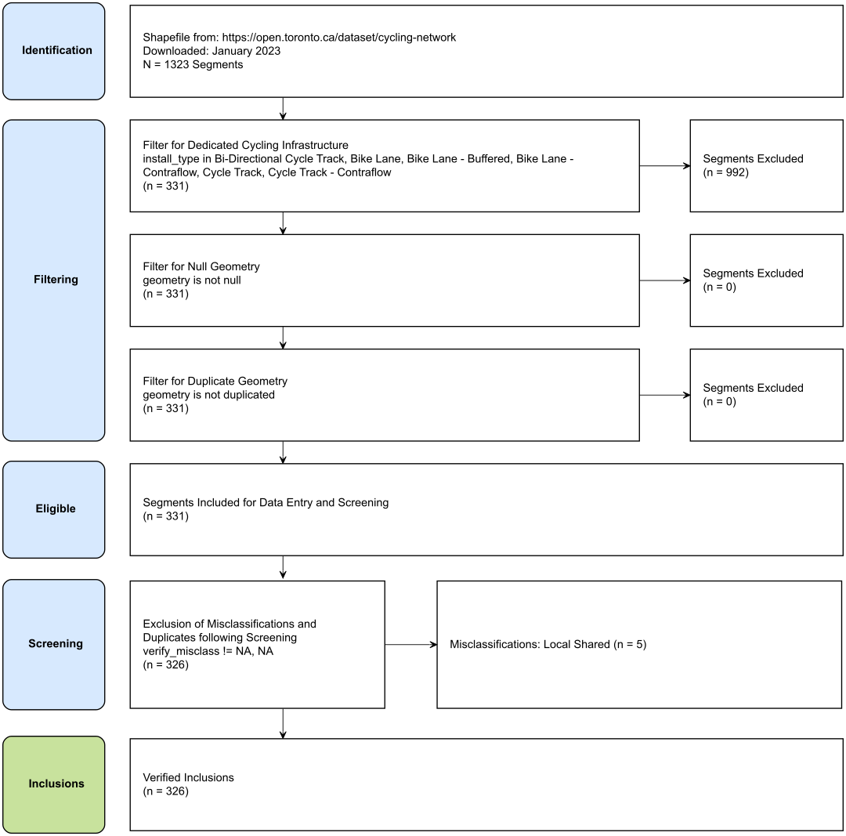

|  |
| --- |
| ***Criteria for Classifying Infrastructure*** |
| **Overview of Steps**  Infrastructure Classification Steps:   * Classify dedicated on-street cycling infrastructure types as either a painted lane, buffered painted lane, or cycle track based on the criteria listed below. Where dedicated on-street cycling infrastructure is absent for a specific segment, the segment will be classified as a shared road, and excluded if it did not receive a subsequent upgrade to a dedicated cycling infrastructure type. Where the cycling facility is located >10 m from a roadway or is denoted for shared use with pedestrians, the segment will be excluded. * If differing infrastructure types exist on either side of the road, categorize the segment based on the most protective element of dedicated cycling infrastructure: Cycle Track (most protective) > Buffered Painted Lane > Painted Lane > Shared Road. * When different infrastructure types are observed along one side of a roadway segment, the classification will rely on the predominant infrastructure type present along the majority of the route, with infrastructure present at intersections excluded from consideration. |
| **Criteria for Painted Lane, Modified from Can-BICS** (15)**:**  A cycling facility can be considered a painted bike lane if the design is consistent with the following features:   1. Lane Demarcation: Solid or dashed lane line(s).    1. Lane may be solid or dashed on the travel lane side. 2. Route Signage and Pavement Markings: Lane must include either of the following at the site or between the site and nearest intersection (≤ 250 m from the site):    1. Bicycle symbols painted on the road (reserved lane diamond optional).    2. Reserved lane sign (for bicycles) or bicycle symbols on signs (cycling route wayfinding signs).    3. Shoulders lacking any bicycle stencils or signage as outlined above are considered ‘paved shoulders’ and should not be considered cycling infrastructure. 3. Auto parking prohibited: Curbside motor vehicle parking is prohibited with 'no parking' or 'no stopping' signs or equivalent pavement markings.    1. Only applicable to painted bike lanes adjacent to the curb, without a designated parking lane. |
| **Criteria for Buffered Painted Lane:**  A cycling facility can be considered a buffered bike lane if the design is consistent with the following features of a painted lane, in addition to:   1. Lane Demarcation: Solid lines    1. Lane must be buffered on the travel lane side and may be unbuffered or buffered on parking lane side (if parking is available).    2. The buffered delineation measures a minimum width of 1 foot (> 30 centimeters) and exhibits diagonal striping or chevron markings. |
| **Criteria for Cycle Track, Selected from Can-BICS** (15)**:**  A cycling facility can be considered a cycle track if the design is consistent with the following features:   1. Physical Separation: The cycle track is physically separated from the roadway (the portion of the road that vehicles can travel) and this ***separation has a vertical component.***    1. Where automobile parking is the physical separation, permanent vertical elements such as bollards, a curb, raised median, planter boxes, or street furniture (e.g., bike share station) must also be present along the street segment (the area between intersections).    2. Where bollards provide the physical separation, bollard spacing must be ≤ 6 m (about the length of a passenger car/truck), otherwise, consider the facility a ‘painted bike lane’ (roadway lane designated for cyclists without physical separation).    3. The facility may bend-in toward the roadway upstream of the intersection, an unprotected distance not exceeding 10 m (about two car lengths), otherwise, consider the facility a ‘painted bike lane’.    4. If the facility is located between automobile parking and a travel lane, regardless of the physical separation used, consider the facility a ‘painted bike lane’. 2. Right-of-Way: Part of the road and located ≤10 m from the roadway (i.e., street buffer width cannot exceed ten metres). |

|  |
| --- |
| ***Criteria for New Installations, Upgrades, and Installation Periods*** |
| **Definition of a New Installation**   * A new installation refers to the introduction of dedicated on-street cycling infrastructure on a road where no prior dedicated on-street cycling infrastructure existed within the period of interest (2009-2022). * In cases where dedicated on-street cycling infrastructure is already in place at the beginning of the study period, the installation year will be designated as the first year of the study period (2009).   **Definition of an Upgrade**   * An upgrade refers to the modification of a segment with existing dedicated on-street cycling infrastructure, resulting in a different classification. This study considers potential classifications as either a cycle track, buffered painted lane, or painted lane. While commonly associated with the installation of more protective infrastructure, this definition is not limited to such cases.   **Determining an Installation Period:**   * An installation period refers to a specific year, a time range within a year, or a precise date when a bikeway undergoing modifications that meet the criteria of a new installation or upgrade becomes available for cyclists to use.   + An installation period can be confirmed visually through historical imagery or through written sources such as construction notices, policy documents, news articles, or other forms of grey literature. When utilizing historical imagery to ascertain the installation period, a time range is defined between the most recent image displaying the previous infrastructure and the earliest image featuring the new cycling infrastructure.   + In cases where ambiguity between different sources arises, (1) priority will be given to sources that provide direct confirmation of completion, such as completion notices, news articles announcing cycling route openings, or imagery, over those that suggest intended, planned, or approximate dates, (2) if this criterion is met and there remains ambiguity, the installation period will be defined as the most recent or earliest date or time range when a bikeway was accessible for use by cyclists. All other factors considered, the source with the greatest precision will take precedence. |

|  |
| --- |
| ***Table 1 Methodology and Classifications*** |
| **Census Populations:**  Data Source: Statistics Canada (2021): https://www12.statcan.gc.ca/census-recensement/2021/dp-pd/prof/index.cfm?Lang=E |
| **Vancouver Street Centreline Calculation Methods**  ***Data Source(s):*** 2 Source Files  Public Streets (Last Updated July 24, 2023): <https://opendata.vancouver.ca/explore/dataset/public-streets/information/?location=16,49.24772,-123.19169>   * Filter: From public streets (n=17,032), select where streetuse != Closed (n=17,028)   Lanes (Last Updated June 13, 2022): <https://opendata.vancouver.ca/explore/dataset/lanes/information/?location=15,49.24423,-123.1524>   * Include all: (n=7,842)   ***Length Calculations:*** Calculate Geometry Attributes – Geodesic Length (km) in ArcGIS Pro 3.0.1  ***Classifications:***  Arterial Road: [from Public Streets – Filtered] streetuse == "Arterial"  Collector Road: [from Public Streets – Filtered] streetuse == "Collector", “Secondary Arterial”*  Local Road: [from Public Streets – Filtered] streetuse == "Residential", "Leased", "Recreational", [from Lanes] all-included  (*) The classification of secondary arterial roads as part of the collector category was determined through a random evaluation of several secondary arterial roads. These roads were frequently situated within residential areas, featured residential driveways, included a median divider with no additional lane markings, and hosted community facilities such as schools, recreational areas, and community centers. This decision helped maintain consistent classification practices across municipalities. |
| **Vancouver Routes Centreline Calculation Methods**  ***Data Source(s):*** 1 Source File  Vancouver Bikeways (Downloaded May 2023): <https://opendata.vancouver.ca/explore/dataset/bikeways/information>   * Include all: (n = 3666)   ***Length Calculations:*** Calculate Geometry Attributes – Geodesic Length (km) in ArcGIS Pro 3.0.1  ***Classifications:***  Cycle Track: Bikeway Type == “Protected Bike Lanes” & Subtype != “OSB”, “OSS”  Painted Lane: Bikeway Type == “Painted Lanes”  Off Street, Path: Bikeway Type == “Protected Bike Lanes” & Subtype == “OSB”, “OSS”  On Street, Shared: Bikeway Type == “Shared Lanes”, “Local Street” |
| **Calgary Street Centreline Calculation Methods**  Street Definitions: <https://www.calgary.ca/planning/transportation/road-classification.html>  ***Data Source(s):*** 1 Source Files  Calgary Centreline: Last Updated July 1, 2023 (from: <https://data.calgary.ca/Transportation-Transit/Street-Centreline/4dx8-rtm5>)   * Filter: From Calgary Centreline (n=115,948), select where ctp_class != Skeletal Roads & Ownership != Private (n=87, 463)   ***Length Calculations:*** Calculate Geometry Attributes – Geodesic Length (km) in ArcGIS Pro 3.0.1  ***Classifications:***  [From Calgary Centreline – Filtered]  Arterial Road: ctp_class == "Arterial Street", "Industrial Arterial", "Local Arterial", "Parkway", "Urban Boulevard"  Collector Road: ctp_class == "Neighbourhood Boulevard", "Collector", "Primary Collector"  Local Road: ctp_class == "Access Route", "Residential Street", "Activity Center Street", "Historic Road Allowance", "Lanes (Alleys)", "Industrial Street" |
| **Calgary Routes Centreline Calculation Methods**  ***Data Source(s):*** 2 Source Files  Calgary Bikeways (Downloaded January 2023): <https://data.calgary.ca/Transportation-Transit/Calgary-Bikeways/jjqk-9b73>   * Filter: From Calgary Bikeways (n = 4170), select where bicycle_cl != “DECOMISSIONED”, “TEMPORARY” (n = 4161)   Calgary Parks Pathways (Last Updated August 2023): <https://data.calgary.ca/Recreation-and-Culture/Parks-Pathways/qndb-27qm>   * Filter: From Calgary Parks Pathways (n=15, 828) select where life_cycle != PLANNED, maintained begins with “CALGARY”, material != TO BE IDENTIFIED (n = 15, 828)   ***Length Calculations:*** Calculate Geometry Attributes – Geodesic Length (km) in ArcGIS Pro 3.0.1  ***Classifications:***  Cycle Track: [from Calgary Bikeways – Filtered] bike_cl == "Cycle Track"  Painted Lane: [from Calgary Bikeways – Filtered] bike_cl == "Bicycle Lane"  On street Bikeway: [from Calgary Bikeways – Filtered] bike_cl == "Neighbourhood Greenway", "On-Street Bikeway", "On-Street BIkeway", "Shared Lane"  Off-street paths: [from Calgary Parks Pathways – Filtered] include all |
| **Toronto Street Centreline Calculation Methods**  Definitions: https://www.toronto.ca/services-payments/streets-parking-transportation/traffic-management/road-classification-system/about-the-road-classification-system/  ***Data Source(s):*** 1 File  Toronto Centreline: Last Updated May 3, 2023 (from: <https://open.toronto.ca/dataset/toronto-centreline-tcl/>)   * Filter: From Toronto Centreline (n = 70,974), select where Jurisdi37 == “CITY OF TORONTO”, Feature36 != “Collector Ramp”, “Busway”, “Creek/Tributary”, “Expressway”, “Expressway Ramp”, “Ferry Route”, “Geostatistical Line”, “Hydro Line”, “Major Railway”, “Major Shoreline”, “Minor Railway”, “Minor Shoreline (Landlocked)”, “Pending”, “River”, “Trail”, “Walkway” (n – 45, 639)   ***Length Calculations:*** Calculate Geometry Attributes – Geodesic Length (km) in ArcGIS Pro 3.0.1  ***Classifications:***  [From Toronto Centreline – Filtered]  Arterial Road: FEATURE36 == "Major Arterial", "Major Arterial Ramp", "Minor Arterial", "Minor Arterial Ramp"  Collector Road: FEATURE36 == "Collector"  Local Road: FEATURE36 == "Access Road", "Other", "Laneway", "Local" |
| **Toronto Routes Centreline Calculation Methods**  ***Data Source(s):*** 1 Source Files  Toronto Bikeways (Downloaded January 2023): <https://open.toronto.ca/dataset/cycling-network/>   * Include all (n = 1323)   ***Length Calculations:*** Calculate Geometry Attributes – Geodesic Length (km) in ArcGIS Pro 3.0.1  ***Classifications:***  [From Toronto Bikeways]  Cycle Track: INFRA_H20 == "Bi-Directional Cycle Track", "Cycle Track", "Cycle Track - Contraflow"  Painted Lane: INFRA_H20 == "Bike Lane", "Bike Lane - Buffered", "Bike Lane - Contraflow"  On street Bikeway: INFRA_H20 == "Sharrows - Arterial - Connector", "Sharrows - Wayfinding", "Signed Route (No Pavement Markings)", "Park Road", "Sharrows"  Off-street paths: INFRA_H20 == "Multi-Use Trail", "Multi-Use Trail - Boulevard", "Multi-Use Trail - Connector", "Multi-Use Trail - Entrance", "Multi-Use Trail - Existing Connector" |

**SUPPLEMENTARY FILES**

Supplementary File: R Code for Figures and Tables (https://rrwen.github.io/recovr-infracycle)